

**Student Name: Leqa’a Abujubbeh**

**Project Name: Deacre**

**Instructors : Ms. Hala Hamdan**

**Mrs. Ahmad Damra**

**Dental clinic website**

**Overview:-**

**- Purpose of the Website:**

It’s a full dynamic website for a dental center services, and booking appointments.

First of all, there will be clinics’, doctors’ information .

Secondly there will be also real patients’ cases before and after clinic sessions.

Thirdly it will contain all contact information, social-media links, location, clinic working hours and frequent questions.

Finally, there will be 2 dashboards one for admin and one for center.

**- Target Audience** :Dental clinics and patients.

**Functionality:**

1. Appointment Booking System: Allow users to schedule appointments online.

2. Before-and-After Gallery: Showcase real patient cases with consent.

3. FAQ Section: Address common questions to improve user experience.

4. Responsive Design: Ensure the site is mobile-friendly.

5. SEO Optimization: Enhance visibility in search engines.

8. Security Features: Protect user data and comply with regulations.

**Features**

1 - Appointment Booking System

- User Flow (Booking)

- Clinic Registration/Login Process

- Accessing Patient Records

2- FAQ Section

- Common Questions and Answers

3- Contact Information

- How to Reach the Clinic

- Social Media Links

7- Admin Accounts

- Dashboard Overview

- Managing Appointments and Content

**Technical Specifications**

2- Technology Stack

- Frontend (HTML, CSS, JavaScript frameworks)

- Backend (MVC ASP.net core)

- Database (MMSQL)

**Security Measures**

- Login Authentication Processes

**User Guides**

1- For Patients

- How to Book an Appointment

2- For Admins

- Managing Gallery Images and Patient’s records

- Handling Appointments

**FAQs for Documentation**

- Common Questions about Website Usage

- Troubleshooting Tips

**Home Page**



1. **Header**
2. Email
3. Phone number
4. Facebook link
5. Instagram link

**2-Navbar to navigate between pages.**

1. Home page
2. About us page
3. Services page
4. Pages : Gallery, FAQ, Team
5. Contact us page
6. Book appointment page

**About us page**

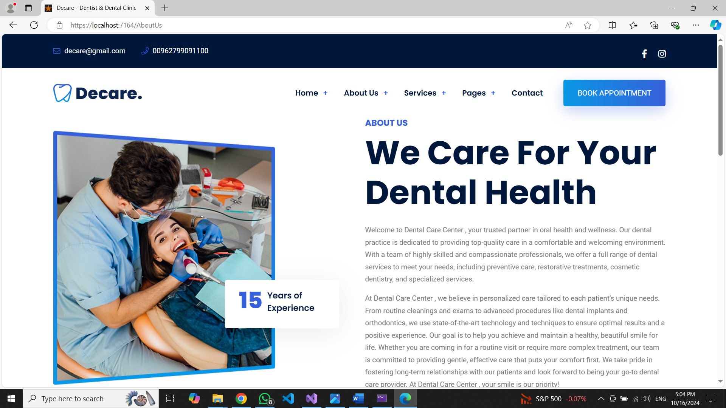

**Services page**

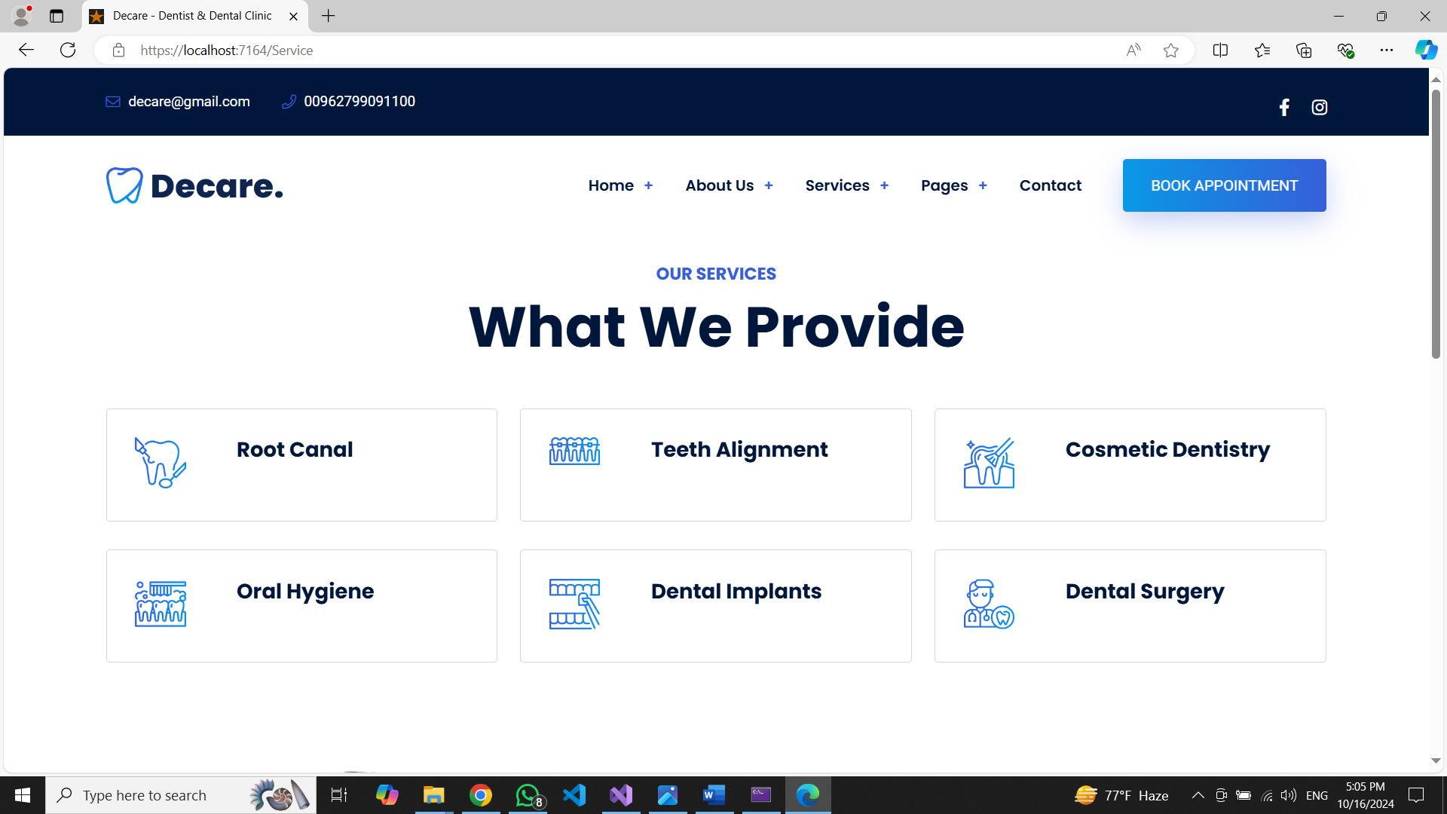

**Each service is a hyper link goes to service’s details page like below**

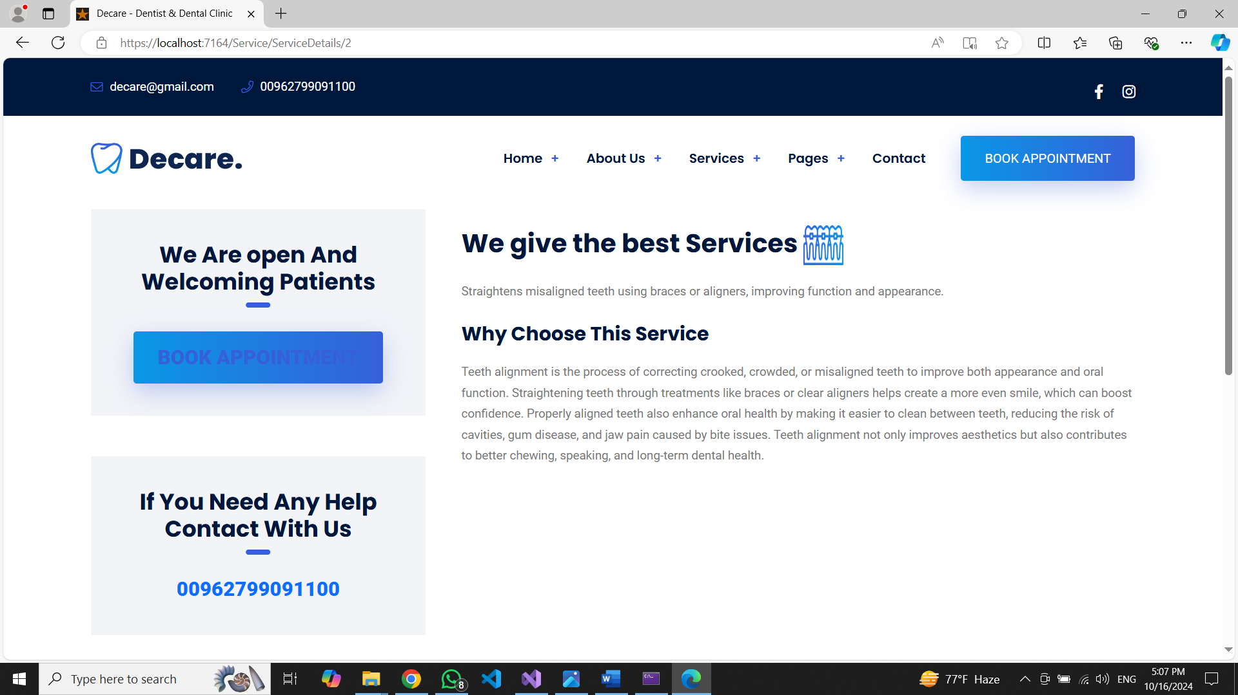

**Gallery page**

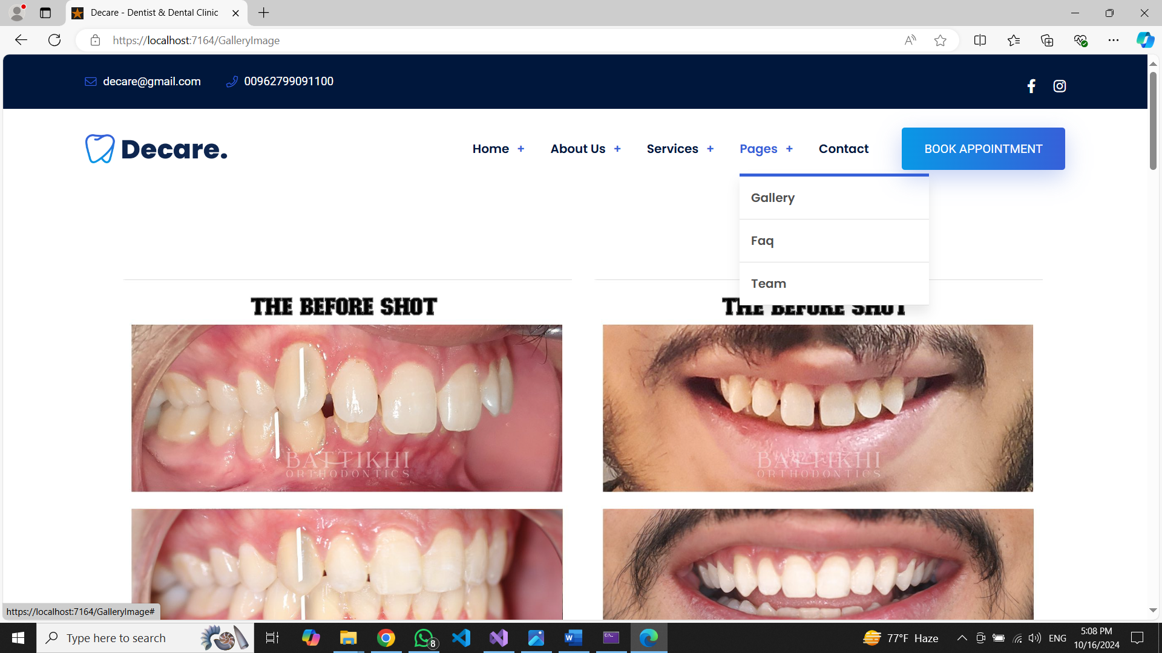

**Faq page**

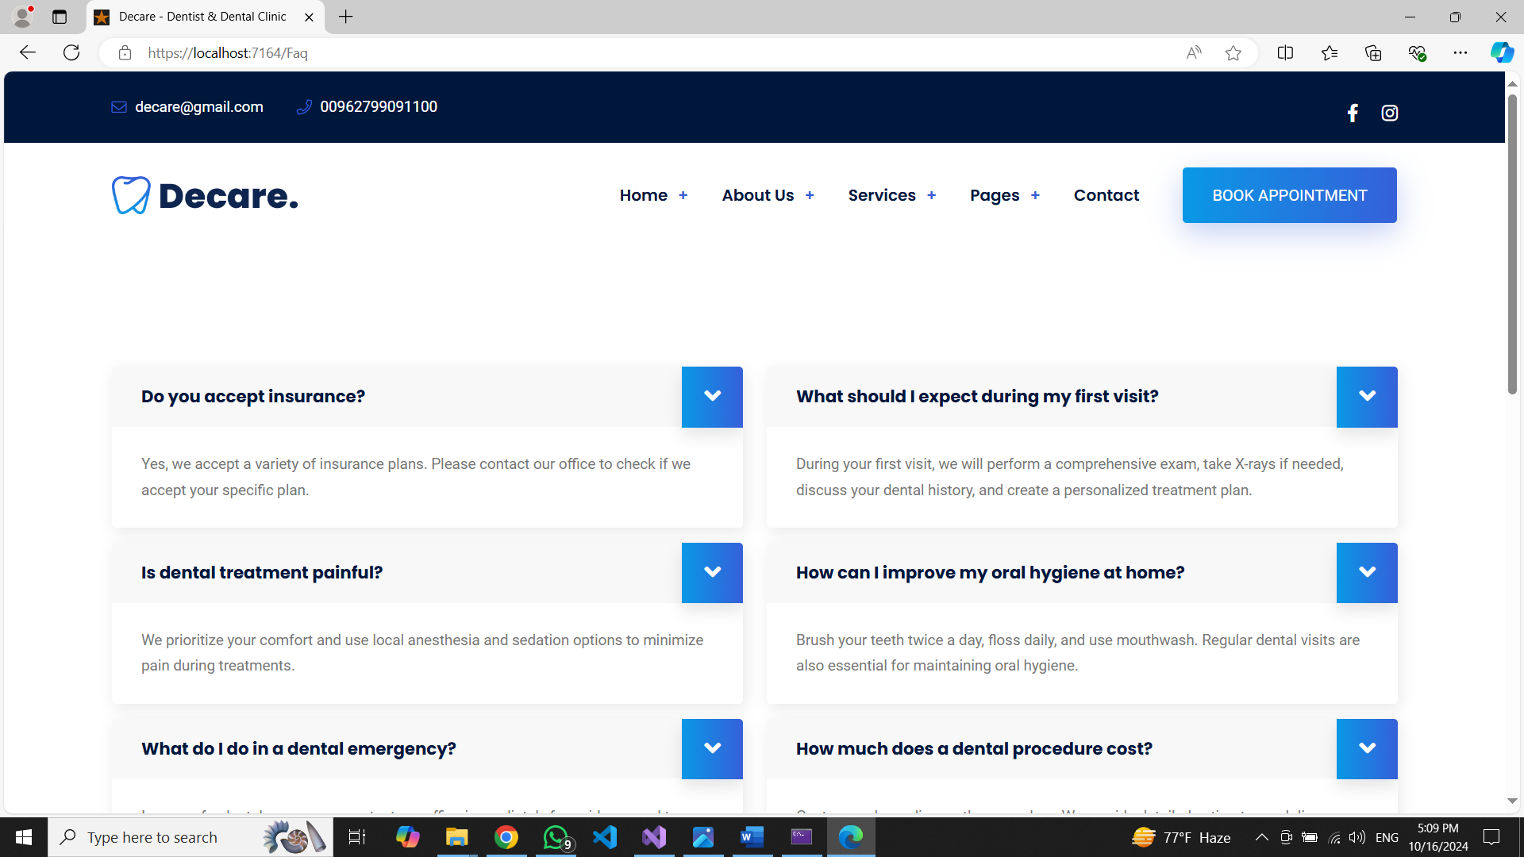

**Team page**

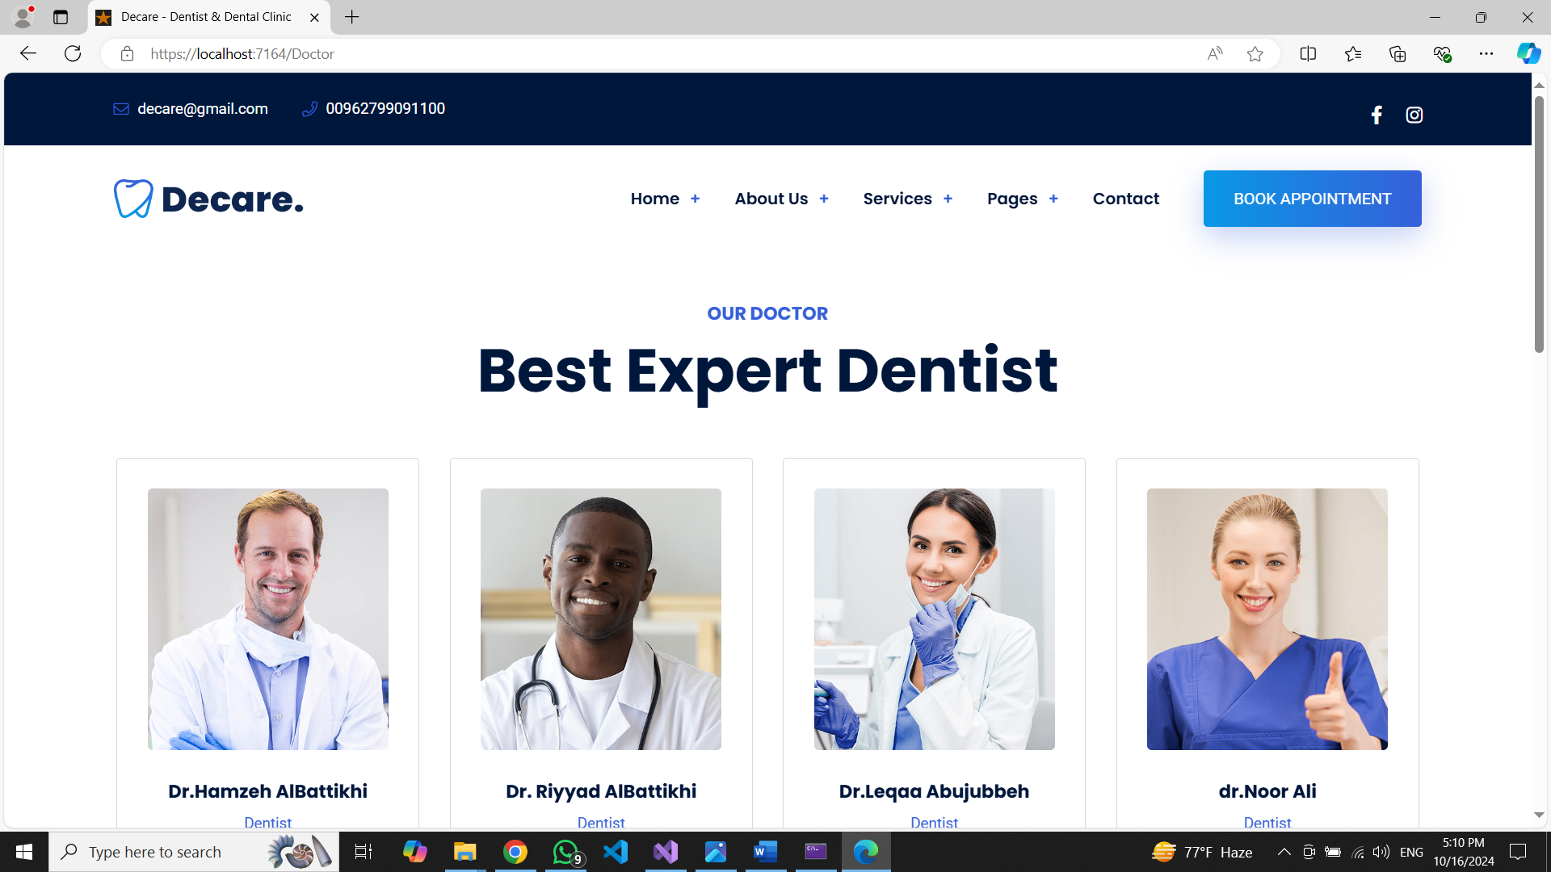

**Each Doctor is a hyper link goes to Doctor’s details page like below**

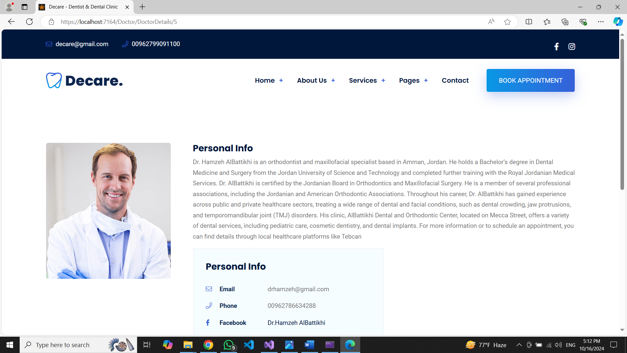

**Contact us page**

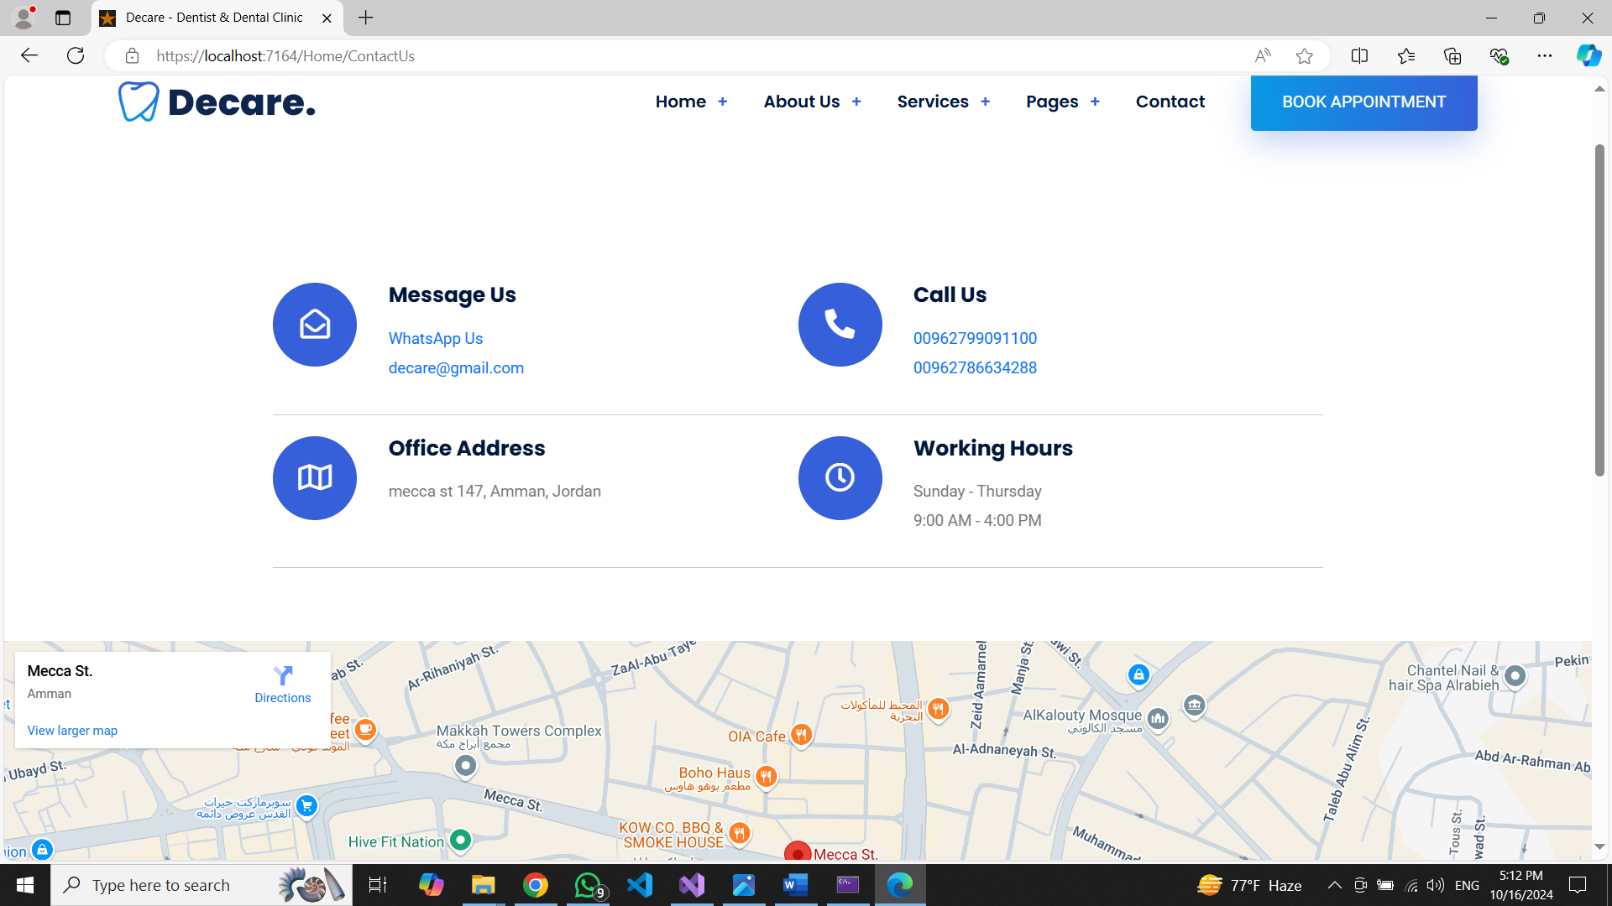

1. **WhatsApp us is a link for chat in WhatsApp**
2. **Decare is a link for mail**
3. **Location**

**Book Appointment page**

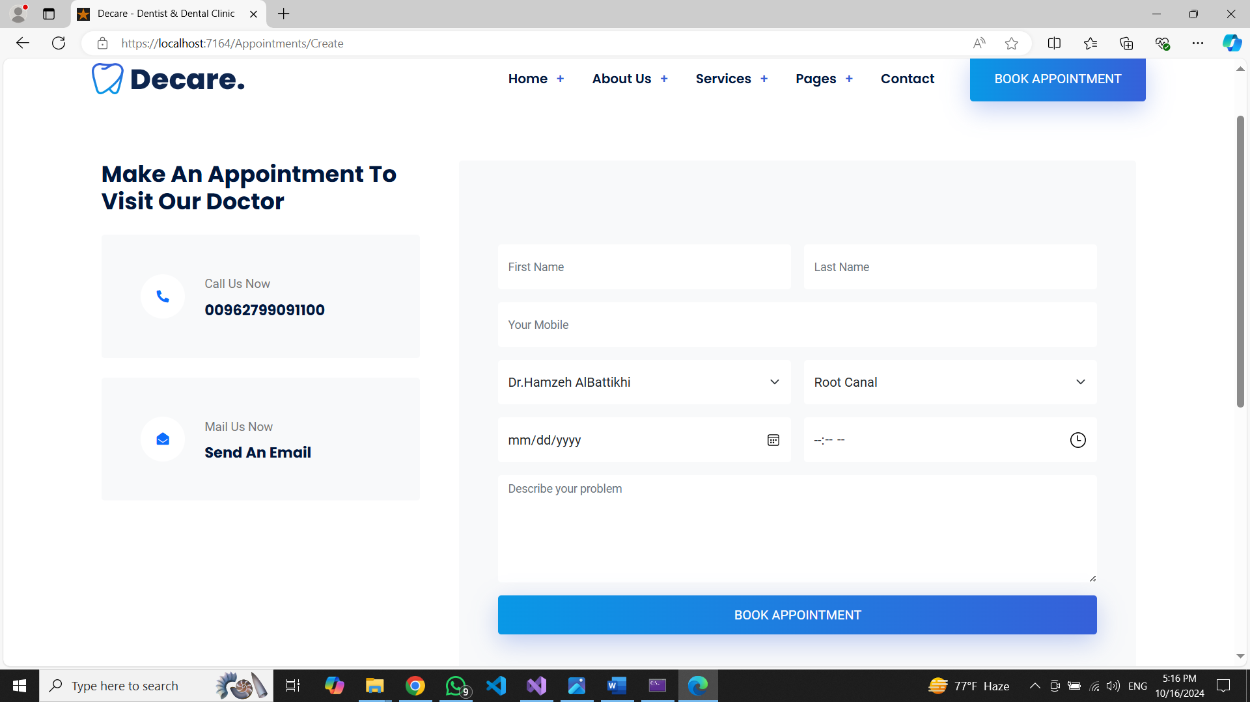

**Successfully book message**

